Title of your contribution

First Author1,2, Second Author2,1, Third Author1

1First affiliation

2Second affiliation

**E-mail:** xxxx@xxxx.xx *(indicate here the e-mail address of the corresponding author)*

**Keywords:** First keyword; Second keyword; Third keyword; Fourth keyword; Fifth keyword.

**Abstract** ***(Intro-Background)*** Replace the text here with an introduction of your work and a brief background to show the context. Replace the text here with an introduction of your work and a brief background to show the context. Replace the text here with an introduction of your work and a brief background to show the context. Replace the text here with an introduction of your work and a brief background to show the context. Replace the text here with an introduction of your work and a brief background to show the context **…** ***(Materials and Methods)*** Replace the text here with a brief description of the materials and methods used in your work. Replace the text here with a brief description of the materials and methods used in your work. Replace the text here with a brief description of the materials and methods used in your work **…** ***(predicted or current Results)*** Replace the text here with a summary of the results obtained from your work. Replace the text here with a summary of the results obtained from your work. Replace the text here with a summary of the results obtained from your work. Replace the text here with a summary of the results obtained from your work **…** ***(possible or drawn Conclusions)*** Replace the text here with the conclusions derived from your work. Replace the text here with the conclusions derived from your work. Replace the text here with the conclusions derived from your work **…**

**The main text of the abstract shall have a length of 300-600 words (figure-, table- and reference words not included)  
The complete submission must have a maximum of 2 pages:**

* **The first page: titre, authors and affiliations, keywords, and the abstract**
* **The second page: figures, tables, and main references**

**Your document must be converted into a PDF file before submission.**

**The yellow-highlighted text is a guideline and should be removed before converting your document to a PDF file.**

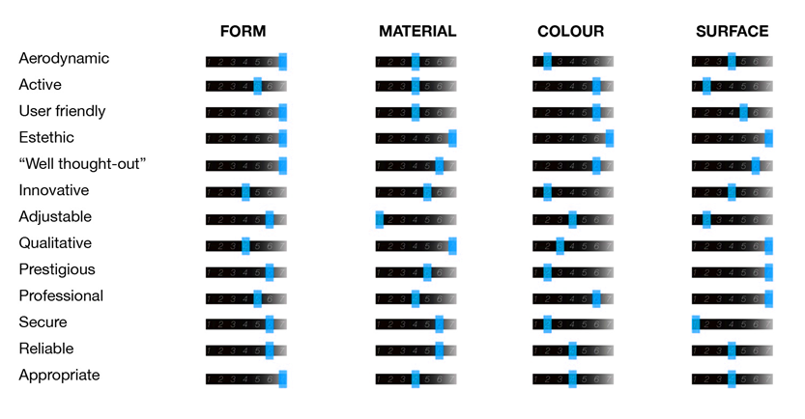

**Figure 1**. Replace the text here with your figure caption [12].

**Table 1.** Replace the text here with your table caption [32].

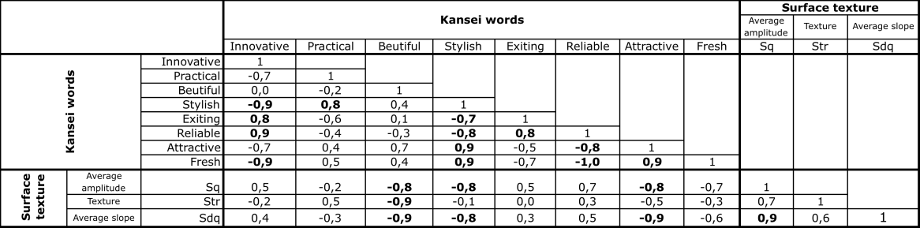

**Main References** *(below an example of reference styles that must be used in this document)*

[1] ISO 9001:2015 (2015) Quality management systems — Requirements.

[2] Nagano H, Okamoto A and Yamada Y (2013) Visual and Sensory Properties of Textures that Appeal to Human Touch International *J. Affective Engineering* **12** 3 pp 375-384

[3] Fechner G T (1897) Vorschule der Aesthetik (Leipzig, Germany: Breitkopf & Härtel)

[4] Stevens S S, Galanter E H (1957) Ratio Scales and Category Scales for a dozen perceptual continua, *J. Exp. Psycol.* **56** pp 328-334

[5] Osgood C E, George J S and Tannenbaum P H (1943) *The Measurement of Meaning* (Urbana IL USA: University of Illinois Press)